Quick Sort

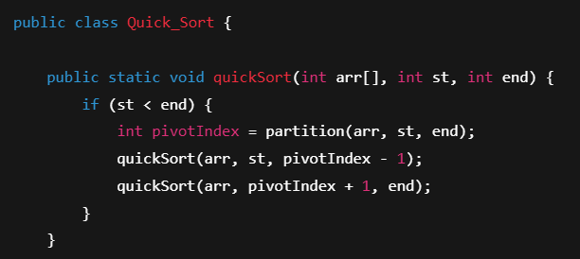

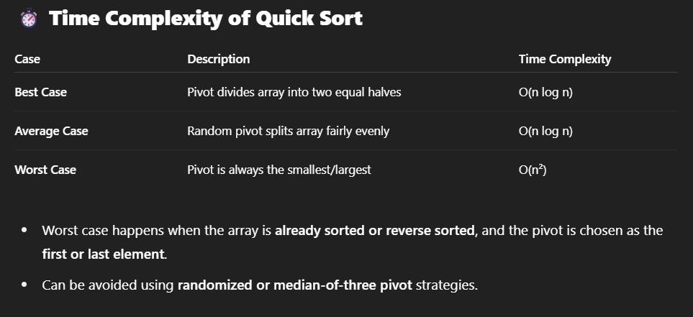

Merge Sort

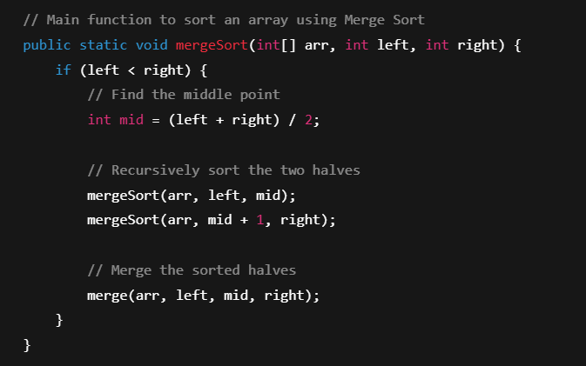

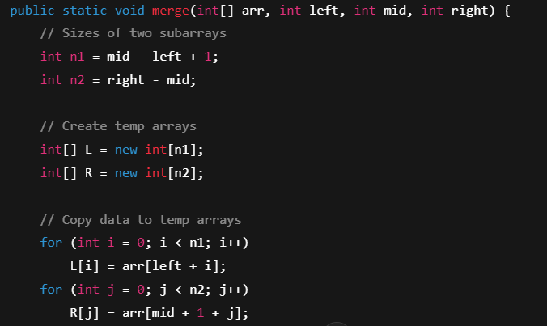

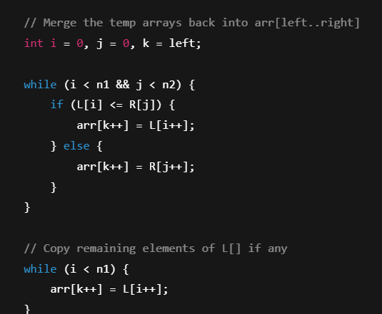

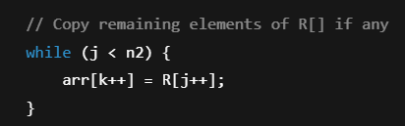

Selection Sort

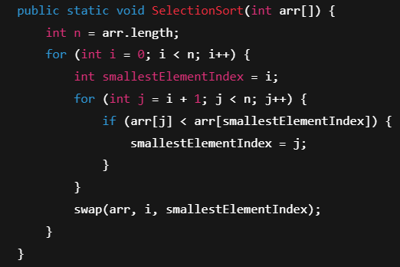

Insertion Sort

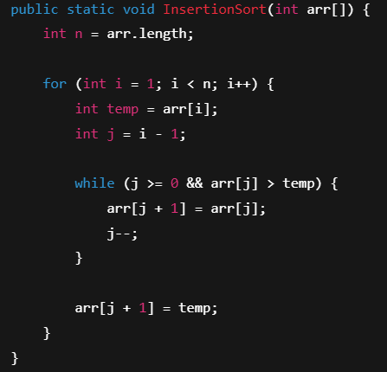

Bubble Sort

